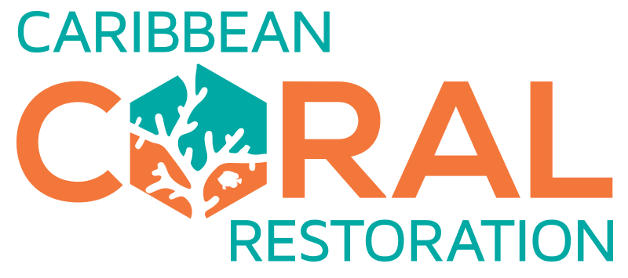

Rotary Reef Sponsorship Form
Thank you for demonstrating your passion for protecting the planet and sponsoring one or more of 118 Rotary Reefs for 118 years of Rotary International. Please note that your contribution to this project will support the Caribbean Coral Restoration Center, Inc. #81-227-1664, a 501c3 nonprofit.

Please fill out the following form and submit it via the same method you obtained the form. Our team will be in touch soon.

How many reefs would you like to sponsor?
1 Rotary Reef for $1950
Multiple Rotary Reefs, each for $1950: Enter number of reefs to be purchases here.

Sponsor Type: Individual, Rotary Club, Organization, or Combination
Please select all that apply.

Individual person
  - Name: Click or tap here to enter text.
  - Email: Click or tap here to enter text.
  - Cell Phone: Click or tap here to enter text.
  - Work Phone: Click or tap here to enter text.
  - Affiliation (if any): Click or tap here to enter text.
Rotary Club*
  - Name: Click or tap here to enter text.
  - District: Click or tap here to enter text.
  - President’s Name: Click or tap here to enter text.
  - Rotary Year: Click or tap here to enter text.
  - Club Email: Click or tap here to enter text.
  - Club Phone: Click or tap here to enter text.
Other Organization*
  - Organization Name: Click or tap here to enter text.
  - Organization Email: Click or tap here to enter text.
  - Organization Phone: Click or tap here to enter text.
  - Contact Name: Click or tap here to enter text.

*By filling out and submitting this form with your signature, you agree that you are an authorized member of your Rotary Club or organization that has the authority to carry out approval of and distribution of payment.

Would you like to include a special dedication for your reef(s)?
Birth of a child
Wedding gift or anniversary
Birthday gift
Dedicated to a loved one who has passed
Graduation gift
Other: Enter other dedication type here.
None

If you selected one or more of the dedication types above, please include all information relevant to the dedication:
Click or tap here to enter text.

Payment Collection Method
GivSum website:
Check and instructions addressed to:
Caribbean Coral Restoration Center, Inc.
2525 Arapahoe Ave
Suite E4-167
Boulder, Colorado 80302

Please select the date by which a GivSum payment will be received and/or a check will be mailed by.
Enter date using MM/DD/YYYY format here.

I confirm that I am authorized as an individual, or by my Rotary Club or organization, to fill out and submit this form, and commit to subsequent payment by the date listed above.

Signature

- Your Name: Type your name here.
- Title: Enter your title within your organization here.
- Organization: Enter the name of your organization here.
- Email: Enter your email here.
- Phone: Enter your phone number here.

- Signature: ________________________________________________________________
- Date: Enter today’s date using MM/DD/YYYY format here.

